OUTPUT

1. Exercise 1

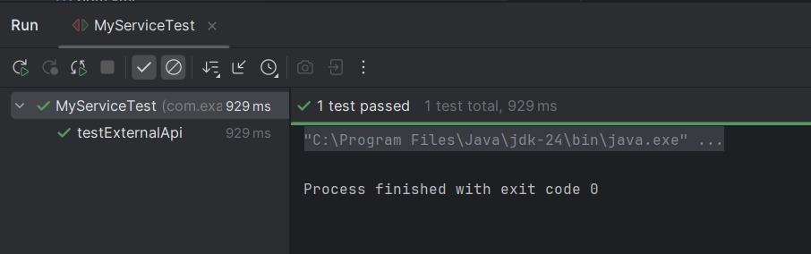

1. Exercise 2s

